

**Progress Report No. 2**

**Integrated Project**

**Course Code ASP3101**

**PROJECT TITLE**

**To make a solar mobile charger**

**SUBMITTED TO: SUBMITTED BY:**

Mrs. Pooja Dhiman SARTHAK CHAWLA 1611981336

ANMOL WADHAWAN 1611981462

**Basic principle**

The solar mobile charger is just device working on the conversion principle of voltage using ICs, diodes, capacitors, resistors and various other electrical equipments in simple words solar panel uses photovoltaic cell or solar cells to convert solar energy in electrical energy. Output of these panels may vary from panels to panels .We can use any of these according to our need. Further we use ICs and other equipments and create a circuit to convert the input power supply coming from the solar panel into the desired power supply i.e. 2 amperes 5 volts dc . Although the adapters we use today for charging our phones today via charging cords i.e. usb wires connected to them, use input ac supply of 100-240 volts ~50-60 hertz 0.35amperes as standard for charging the modern day Smartphone. Many other companies have their own standards for input and output supplies the above one was of well known upcoming brand “MI”. At last we can say that we are basically just converting the supply we get from the solar panels into the ones we require in this case the one for the mobile charger.

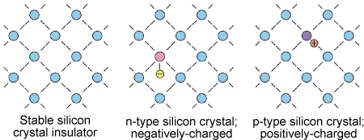

*Fig1: Inside of a solar panel*

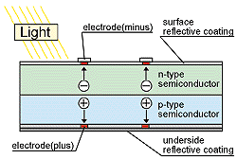

*Fig2: Solar panel placed under sunlight*

There are mainly 2 different forms of solar mobile chargers created so far till now. They all work on same principle but use different approach and have a bit of special features in them varying from charger to charger. The various methods are as follows:

**Method 1:**

In this method solar panel output is directly converted to usable output for charger. It’s simple basic method of creating a solar mobile charger. Steps for this charger are as follows:

Step 1: Make the connections as shown in the circuit diagram.

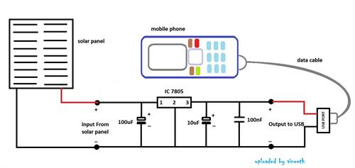

*Fig3: Circuit diagram of method 1*

Step 2: Place the solar panel in the sunlight and wait for the the supply efficient for the charger to be generated.

Step 3: Mobile start getting charged.

**Method 2:**

Here the energy is first stored in batteries then released out in form current to charge the phone. Therefore recharging of batteries happens first then charging of phone takes place. The steps for making this kind of mobile charger are as follows:

Step 1: Place your DC to DC USB Booster Circuit leads in the holes of the breadboard as shown in fig 4

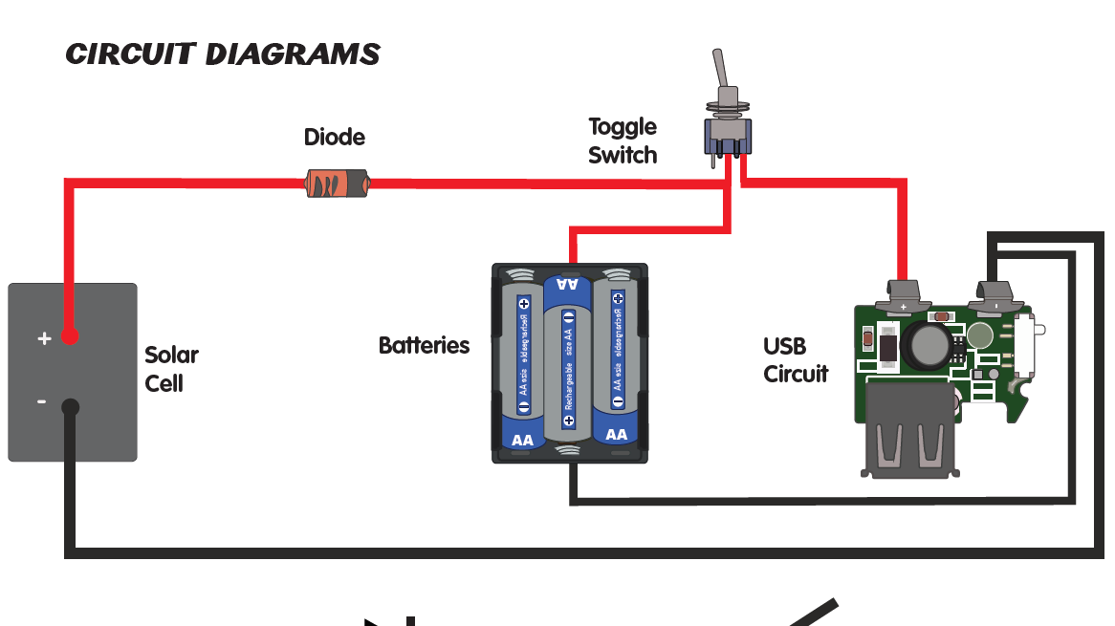

*Fig 4:Circuit diagram*

Step 2: Once Mini Slide Switch pin and leads selected and prepared, place Mini Slide Switch in the breadboard

Step 3: Place the Battery Holder

Step4: Place the N914 Diode in the breadboard

Step5: Place the Solar Panel in the breadboard

Step6: Place AA Rechargeable Batteries in Battery Holder. Now slide your Mini Slide Switch the red LED on your DC to DC USB Booster Circuit will turn on and plug in USB cable and charge small electronic device.

**Choice made:**

We opted method 2 because it provides us with the stored energy although it requires more effort to build but it’s more efficient an worth building. Furthermore it makes us charge our device anytime anywhere required once we charge the batteries inside it via solar panels. Thus utilisation of solar energy via this method for charging our devices is better and may be say one of the best and easy ways to charge our mobiles.

**Further interests:**

I am interested in learning how to make easy, portable and ready to use devices which run on solar power. The scope of imagination is large as solar power can run anything on DC voltage. Specifically, I want to explore solar chargers in greater detail and understand how to increase efficiency of power generation . Another area of interest Is exploring different technologies available in making solar cells( Mono-crystalline, Polycrystalline, Thin Films) and be able to explain why their efficiency changes so much by understanding their crystal structures.

**Bibliography:**

* G. Park”Overview of Energy Harvesting Systems (for Low-Power

Electronics).” Presentation at the First Los Alamos National Laboratory

Engineering Institute Workshop: Energy Harvesting, 2005 .

* Ferro Solutions. “VEH-360: Evaluation Power System Specifications.”
* Hohm, D. P. (2002, November 22). Comparative study of maximum

power point tracking algorithms *Progress in Photovoltaic’s: Research*

*and Applications* , pp. 47-62

* Kansal, D. Potter, and M. Srivastava “Performance aware tasking for

environmentally powered sensor networks”, Proc. ACM International

Conference on Measurement and Modelling of Computer Systems,

* + pp.223– 234, 2004.